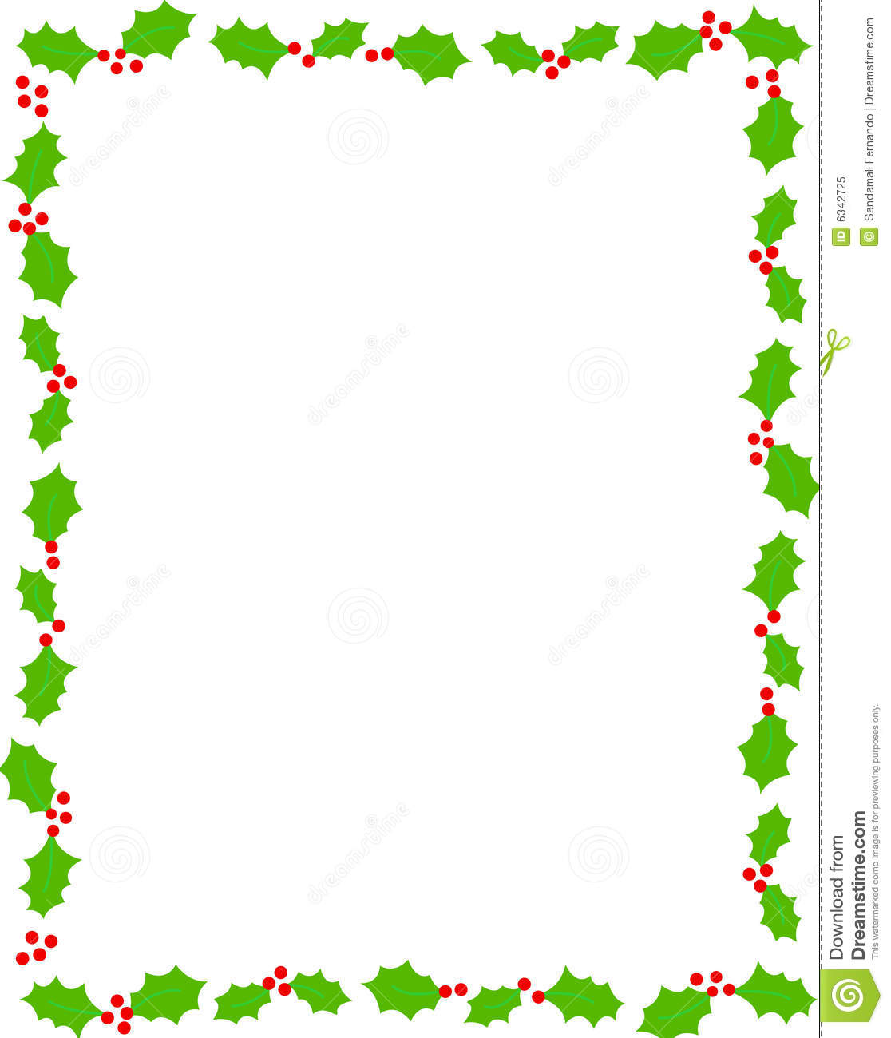

ST. BRIDES VILLAGE
CHRISTMAS CELEBRATION

Please join us for a fun family evening
of Carols and Readings on zoom
at 7.00pm
on Monday 21st December
sorry this year you will have to supply your own
Mince pies & Mulled Wine
Please email one of the below and we will forward you the link
Anna - anna@coryconsultancy.co.uk
Lynne -Lynneandclivemordecai@gmail.com

Wishing you a Happy Christmas and a Healthy New Year

